**Project Design Phase-II Data Flow Diagram & User Stories**

|  |  |
| --- | --- |
| Date | 30 June 2025 |
| Team ID | LTVIP2025TMID37158 |
| Project Name | Transfer Learning-Based Classification of  Poultry Diseases for Enhanced Health  Management |
| Maximum Marks | 4 Marks |

**Data Flow Diagrams:**

**External Entities:**

 **User:** The person who captures or uploads poultry images.

 **Trained Model**: Pre-trained deep learning model (like VGG16/ResNet).

**Processes:**

1. **Image Input –** Accept image input from user.
2. **Preprocessing –** Resize, normalize, and clean the image.
3. **Feature Extraction –** Extract deep features using a pretrained model**.**
4. **Classification –** Identify disease class based on features.
5. **Result Display –** Output the predicted disease to the user.

**Data Stores:**

 **Image Dataset –** Stores poultry disease images used for training/testing**.**

 **Model Weights –** Stores the pre-trained weights and architecture**.**

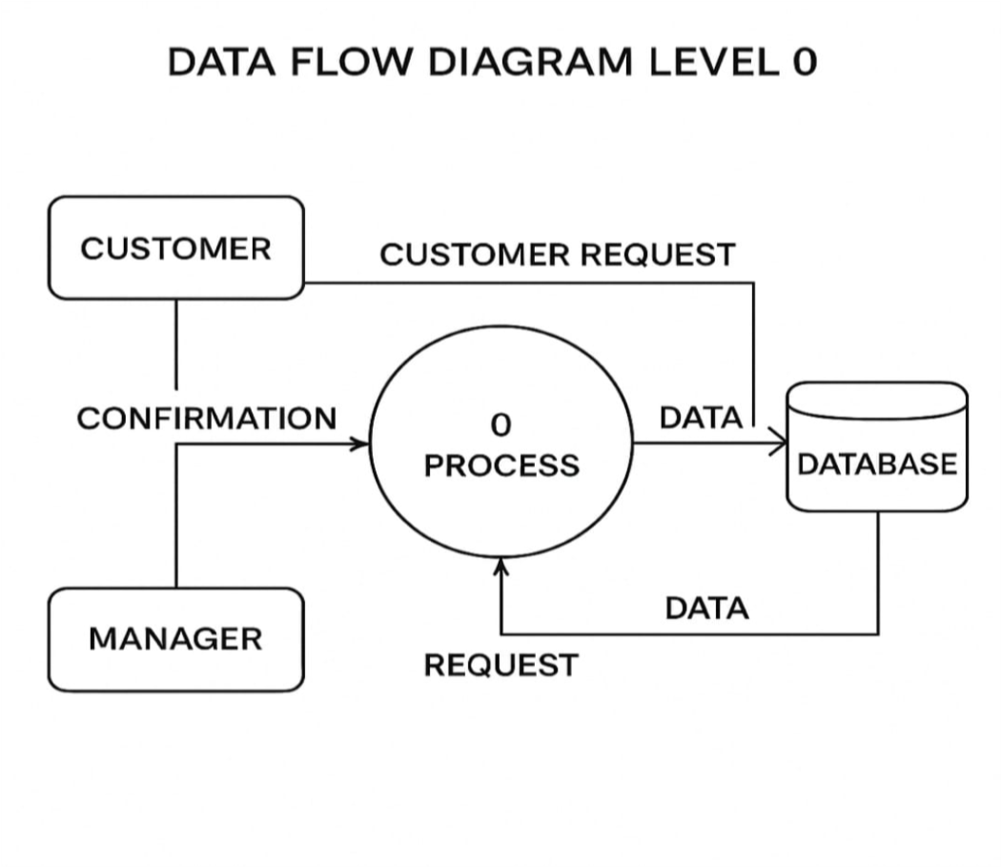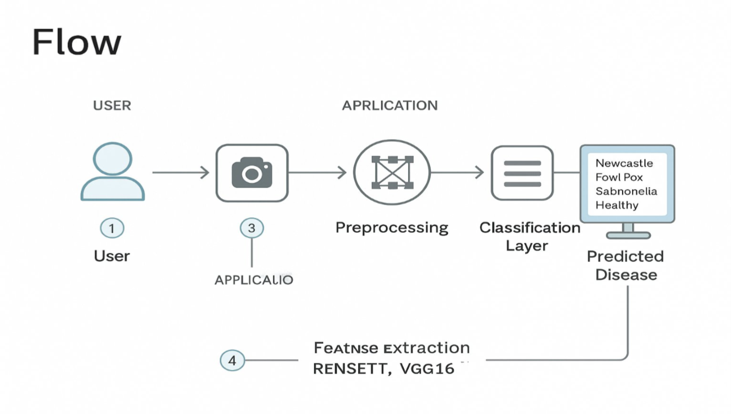

**User Stories**

|  |  |  |  |  |  |  |
| --- | --- | --- | --- | --- | --- | --- |
| **User Type** | **Functional**  **Requirement**  **(Epic)** | **User Story Number** | **User Story / Task** | **Acceptance criteria** | **Priority** | **Release** |
| Farmer  (Mobile/Web  User) | Registration | USN-1 | As a user, I can register by entering email, password, and confirming password. | I can access my  account/dashboard after registration. | High | Sprint-1 |
| Farmer | Login | USN-2 | As a user, I can log in using my registered credentials. | I can enter app and view upload option. | High | Sprint-1 |
| Farmer | Image Upload | USN-3 | As a user, I can upload an image of a chicken. | The image is uploaded and processed. | High | Sprint-1 |
| Farmer | Disease Detection | USN-4 | As a user, I can get the disease name after image upload. | Model gives result  (Healthy / Disease name). | High | Sprint-1 |
| Farmer | Disease  Information | USN-5 | As a user, I can see brief info/tips about the detected disease. | Info page opens with details. | Medium | Sprint-2 |
| Admin | View Uploaded Images | USN-6 | As an admin, I can view all uploaded images and prediction logs. | Admin panel shows image history and predictions. | Medium | Sprint-2 |
| Admin | Manage Users | USN-7 | As an admin, I can block or remove fake/invalid users. | Admin dashboard allows user control. | Low | Sprint-2 |